The Marketing Mix

Chapter 1-3

Fundamentals of Marketing

Objectives

Name:

Class Id:

Class Hour:

* Describe another definition of market
* Differentiate consumer and industrial markets
* Describe market share
* Define target market
* List the components of the marketing mix

**Market (as it pertains to marketing):**

**Two Types of Markets:**

|  |  |
| --- | --- |
| 1. | Definition:  Consumer Markets want Products that: |
| 2. | Definition:  Industrial markets want Products that: |

**Market Share**

Read the article **“What is Market Share”** found on our class web page and complete the following questions:

Define **Market Share**:

Calculate Market Share:

If the industry sales for a Blue-ray player is $4,567,850 and you sold $2,985,000 this year, what is your market share? .

If you own a business that sells video games with $248,000 in sales and the industry sold $1,500,000. What is your market share? .

**Why is market share important? List the three things that occur from the article listed:**



Research shows that the symbol shown here is recognized by 97% of all Americans and that every man woman and child in the US spends an average of $20 a year on products from this company. What is the company? From the article this is called

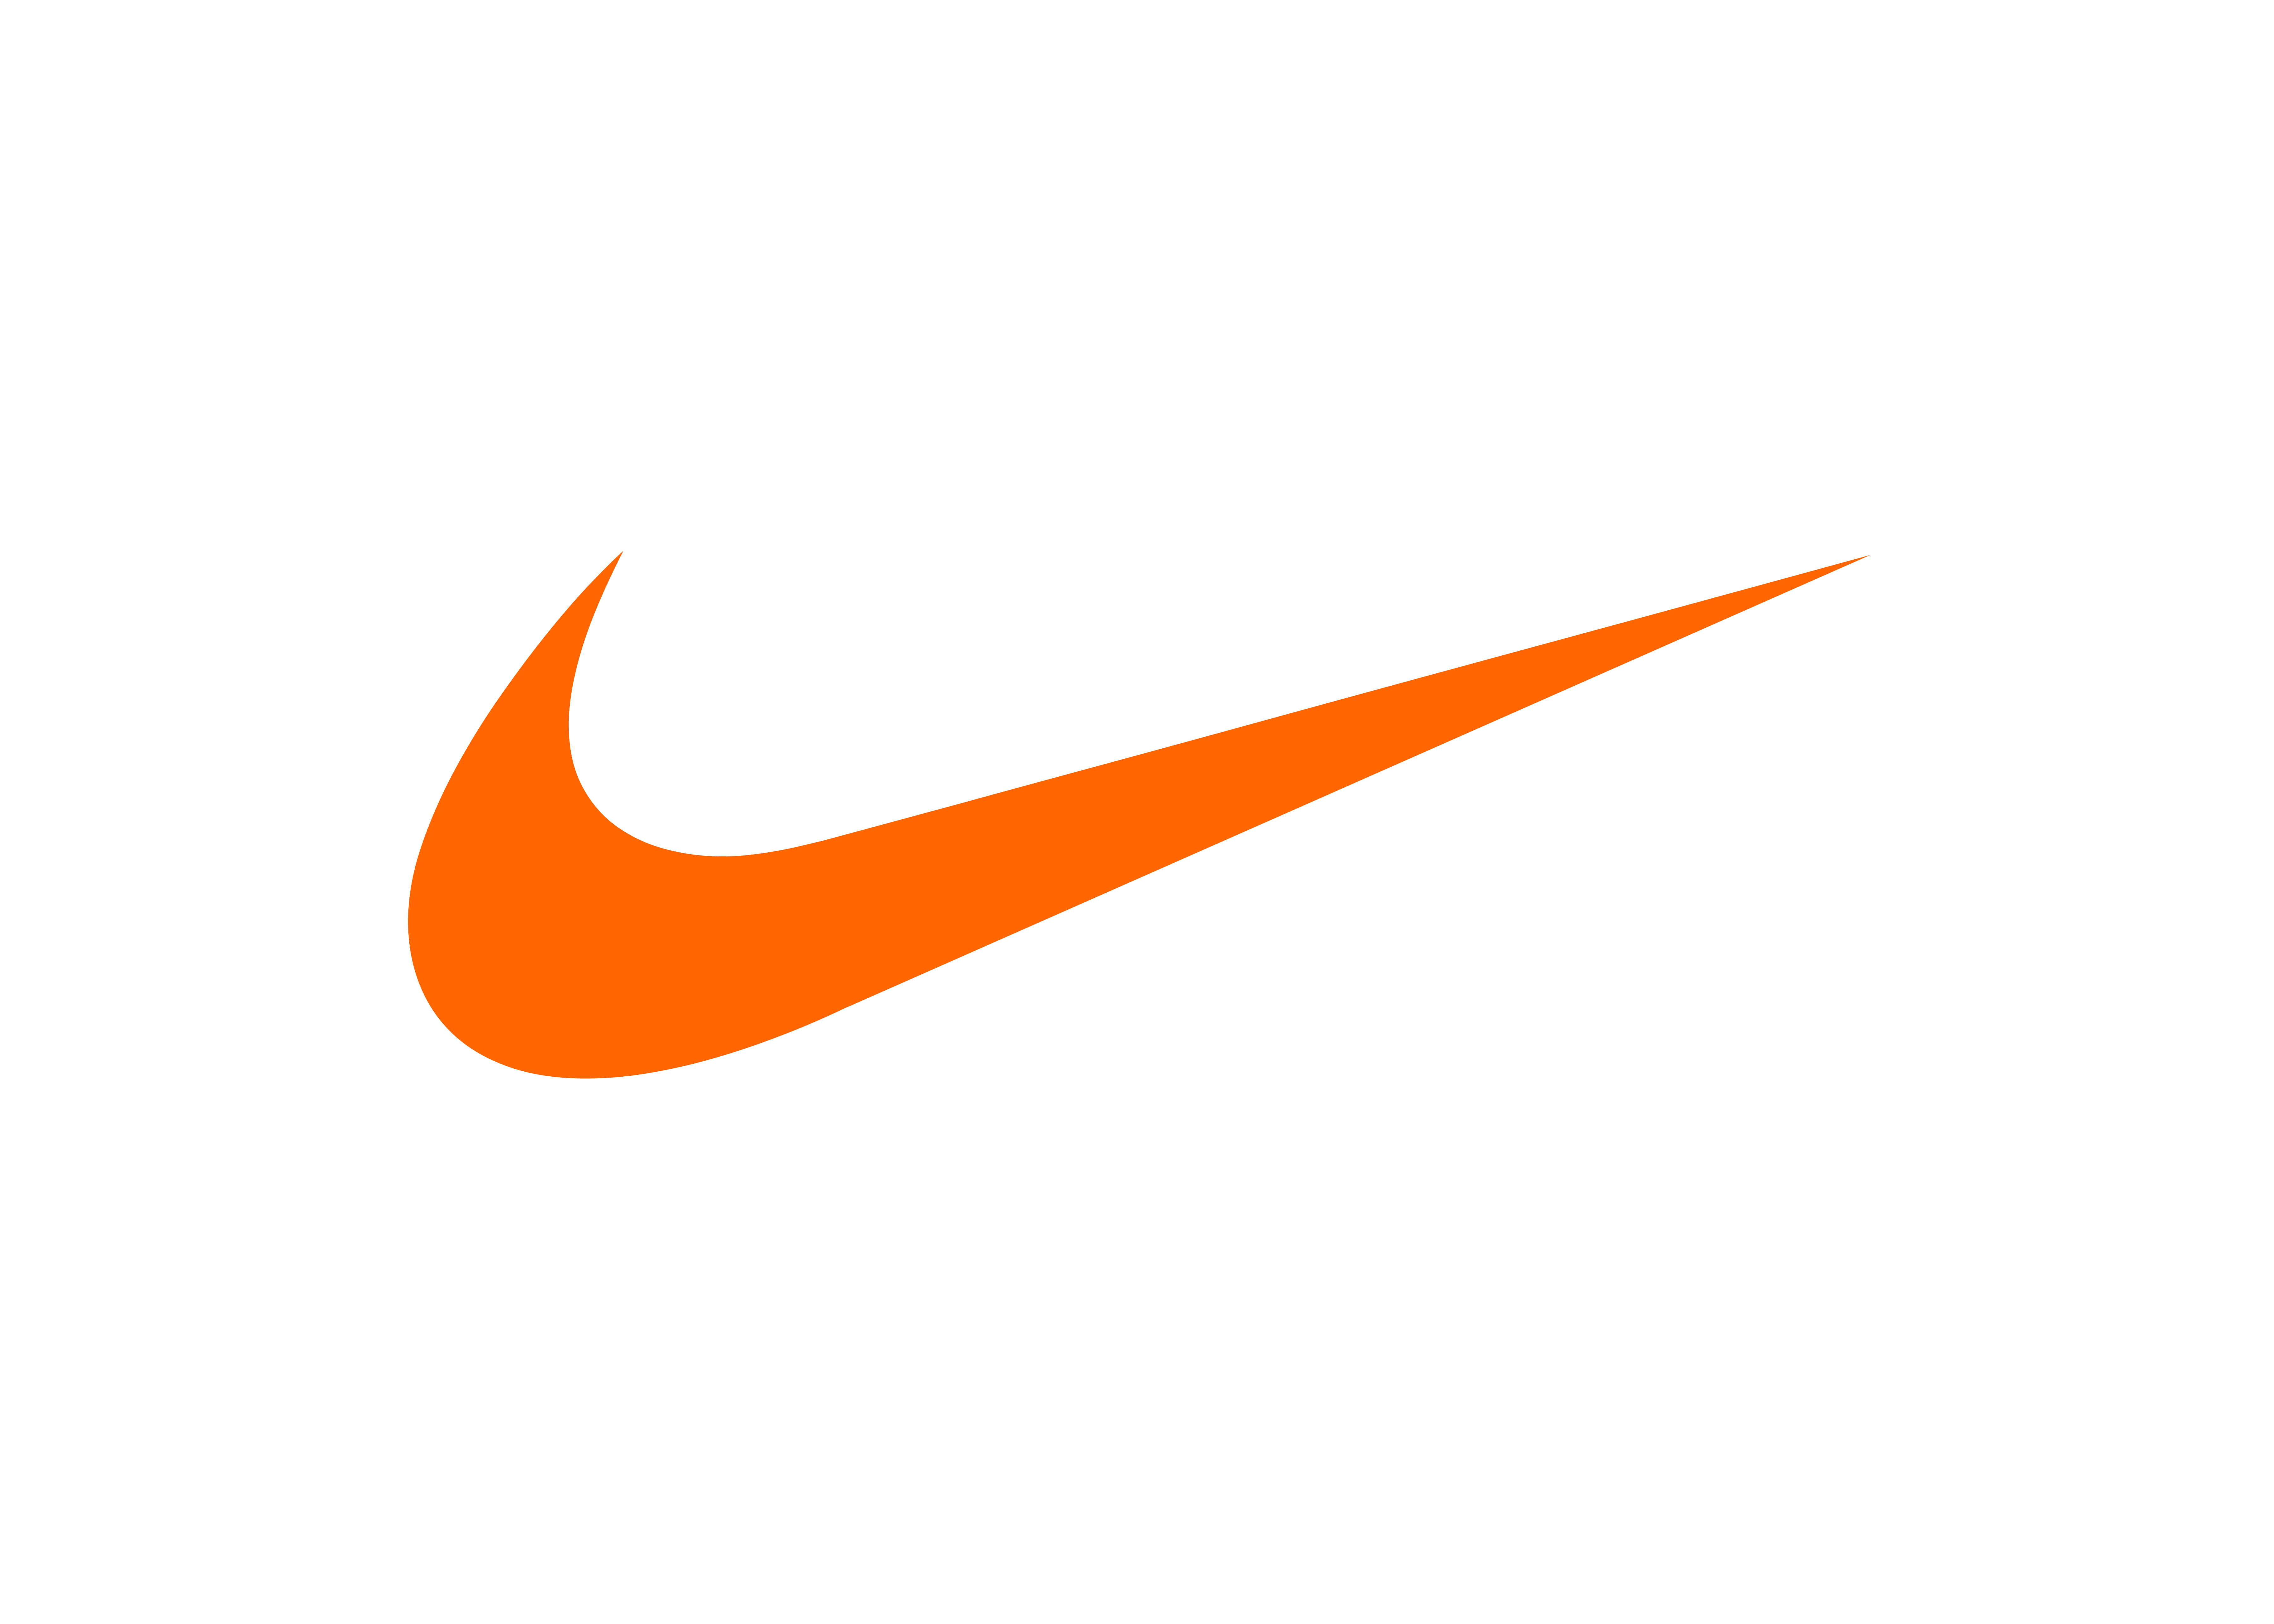

Currently there are approximately 326,866,000 people in the US. How much in dollars do Americans spend on Nike Products?

**Brand penetration (definition):**

**Four business classifications of Market Share:**

|  |  |
| --- | --- |
| Market Leader |  |
| Market Challenger |  |
| Market follower |  |
| Market nicher |  |

Based on what you learned: If the video game market has $1,500,000 is sales. Company X has $375,000 of the market, company Y has $675,000 of the market, you have 248,000.

Who is the market leader at % of the market?

Who do you think is the market challenger? At %.   
What percentage of this business do you have?

You could be classified as a or a   
Are you successful, why or why not?

***Read the article “Cell Phone Market by Operating system”***

***The Leader is at %.***

***Read the article “Cell Phones By Vendor” the leader is at***

***The Market Challenger is what company?***

***The other three phones listed, have you heard of these phones?***

***If no, why not?***

***Read the article Cell Phone Industry Revenue. The Global Smart phone sales value is . Based on how we calculate market share, How much revenue is sold by Samsung***

***Target Market and Market Segmentation***

Market Segmenting:

Target Market

Customer Profile:

Sevan Common ways to segment a market (there are many more these are the most common)

|  |
| --- |
| 1 5  2 6  3 7  4  Customer Profile of markets that purchase a Snowmobile using the 7 Common segmentation:   * + Age :   + Gender:   + Income level:   + Geographic residence:   + Marital Status   + Ethnic background:   + Occupation   + Lifestyle/Interests/Hobbies:   What is the customer Profile of Tesla? Discuss in groups at your table, what do you think the Tesla Customer Profile is that is used to target people to buy their product. Read the description of the car and the pricing.  Tesla is an American [electric vehicle](https://en.wikipedia.org/wiki/Electric_vehicle) and [clean energy](https://en.wikipedia.org/wiki/Clean_energy) company based in [Palo Alto, California](https://en.wikipedia.org/wiki/Palo_Alto,_California).[[8]](https://en.wikipedia.org/wiki/Tesla,_Inc.#cite_note-8) Tesla's current products include electric cars, battery [energy storage](https://en.wikipedia.org/wiki/Energy_storage) from home to grid scale, solar products and related products and services  .  The current Tesla car line (Model S, Model 3, Model X, Model Y) ranges in cost from **$46,000 – $124,000** before tax incentives for electric cars (see the chart on your teachers presentation).   * + Age :   + Gender:   + Income level:   + Geographic residence:   + Marital Status   + Ethnic background:   + Occupation   + Lifestyle/Interests/Hobbies: |

***Marketing Mix:***

The 4 Ps – Fill in the Key Factors from the Edpuzzle video in the spaces below. We will add a few more to them when we review it.

|  |  |
| --- | --- |
| 1. Product | Definition:  Five Key factors from Video  1 5  2 6  3 7  4 8 |
| 2. Price | Definition:  List Key factors from video:   |  |  | | --- | --- | |  |  | |  |  | |  |  |   Consumer Pricing:  Industrial Pricing: |
| 1. Promoiton | Definition:  Seven Promotion options from video |
| 1. Place | Definition:  Seven Place options |

